**Animesh Parab T2-T21 88**

**ASSIGNMENT-3**

**AIM-** To study AWS S3 service and create a bucket for hosing static web application.

**THEORY-**

AWS Simple Storage Service (S3) from the aforementioned list, S3, is the object storage service provided by AWS. It is probably the most commonly used, go-to storage service for AWS users given the features like extremely high availability, security, and simple connection to other AWS Services.

An Amazon S3 bucket can be set up to operate similarly to a website. This section illustrates how to host a website using Amazon S3. There are mainly 7 steps to hosting a static website using Amazon Web Service(AWS) S3.

**STEPS:**

**Step 1: Creating a Bucket**

1. First, we have to launch our S3 instance. Follow these steps for creating a Bucket

2. Open the Amazon S3 console by logging into the AWS Management Console at

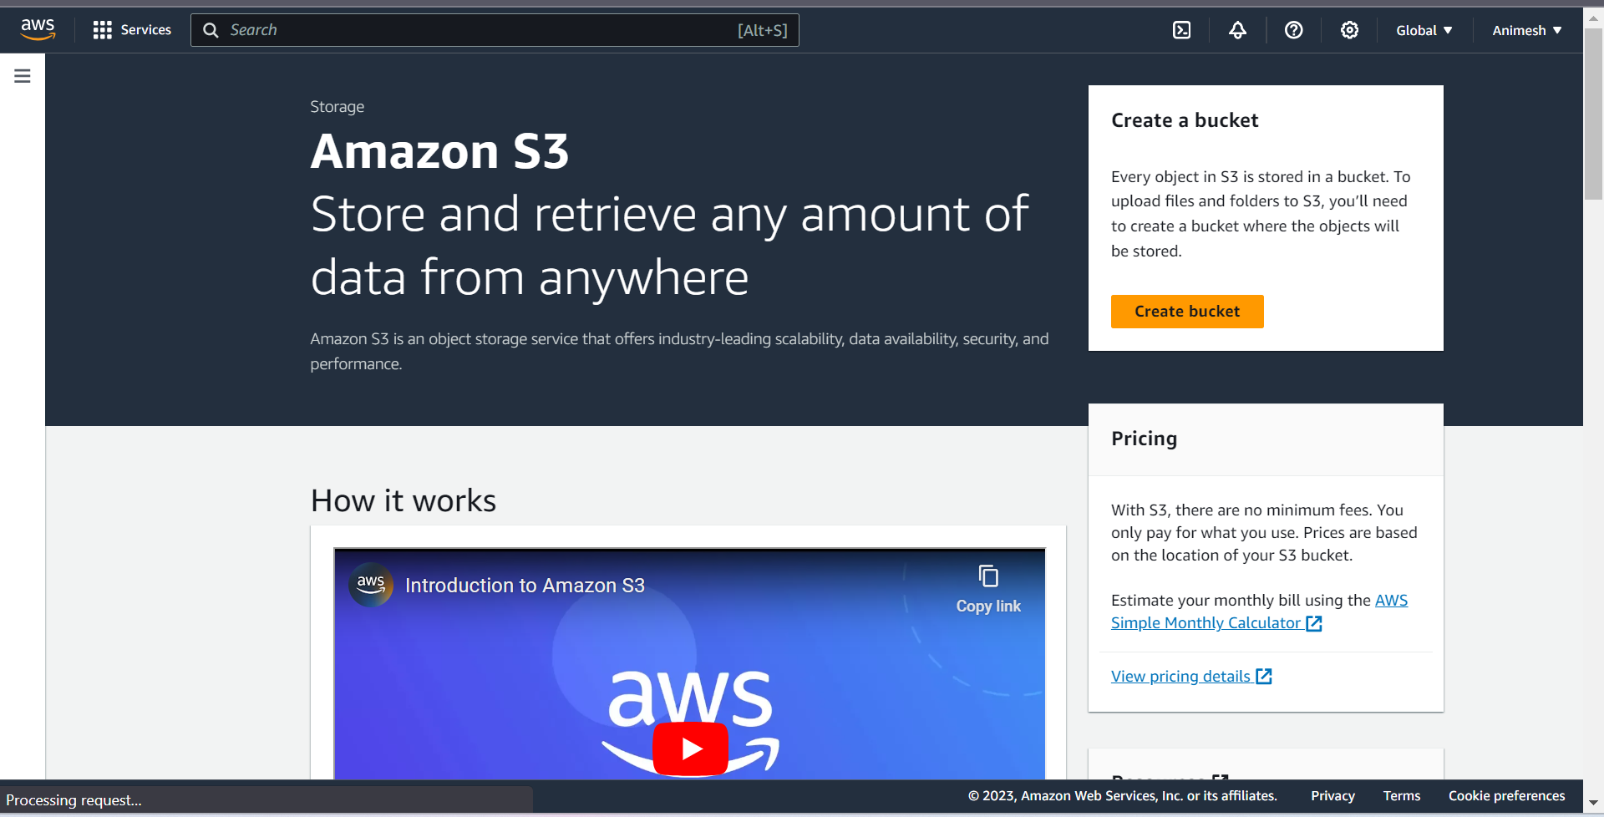

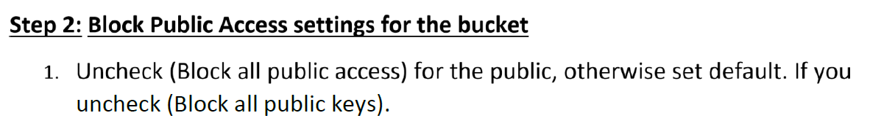

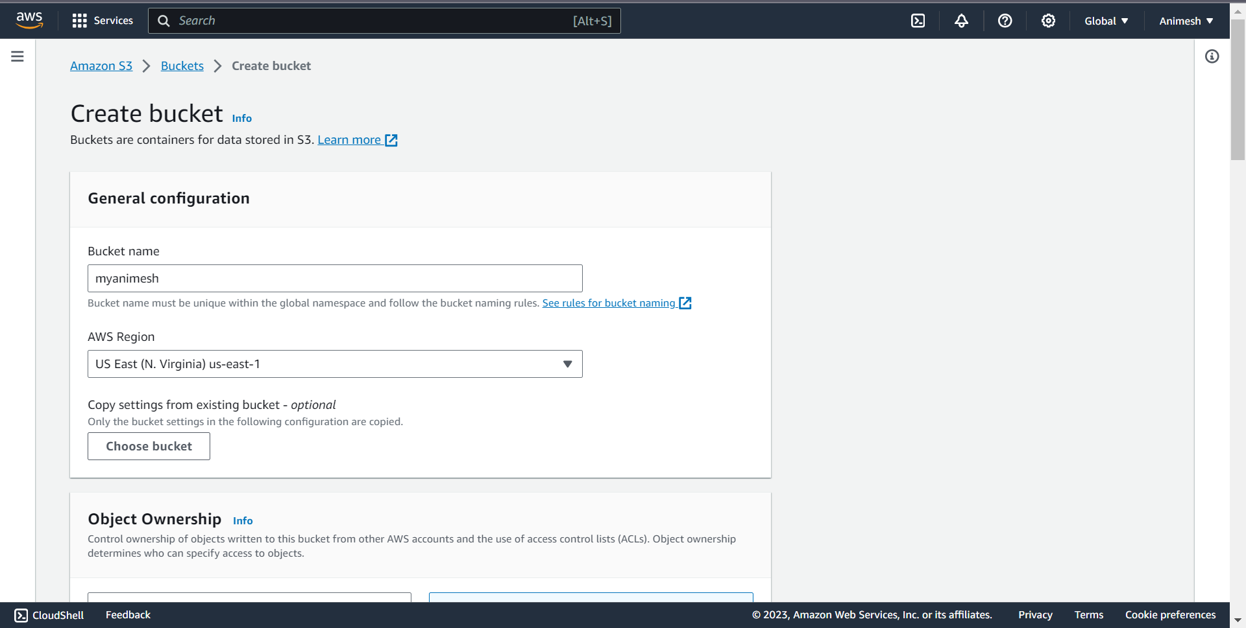

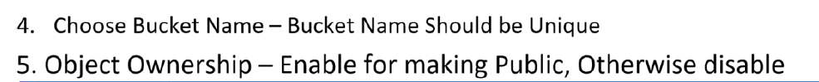

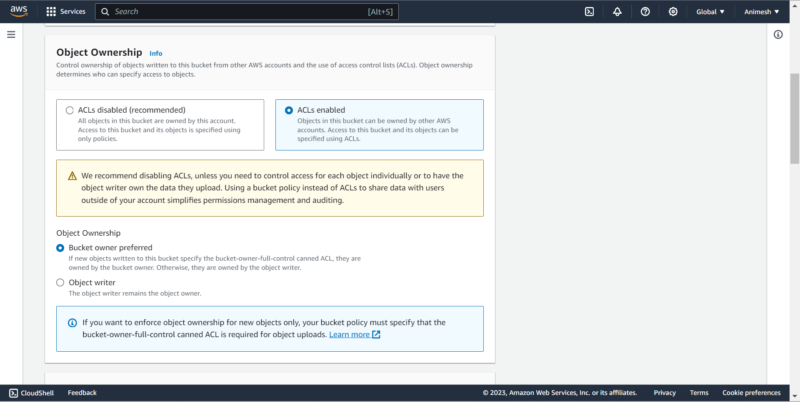

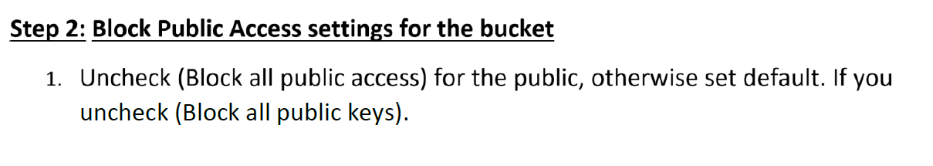

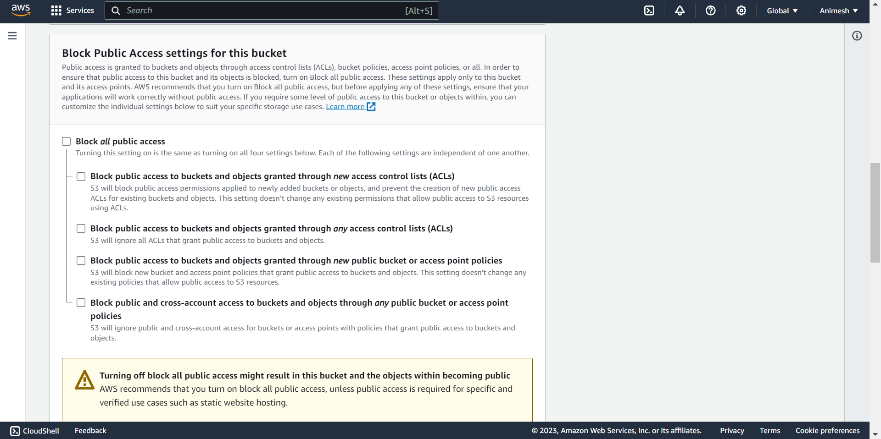

2. Now click on create bucket

Select Bucket and Click your Bucket Name.

3. Bucket is created

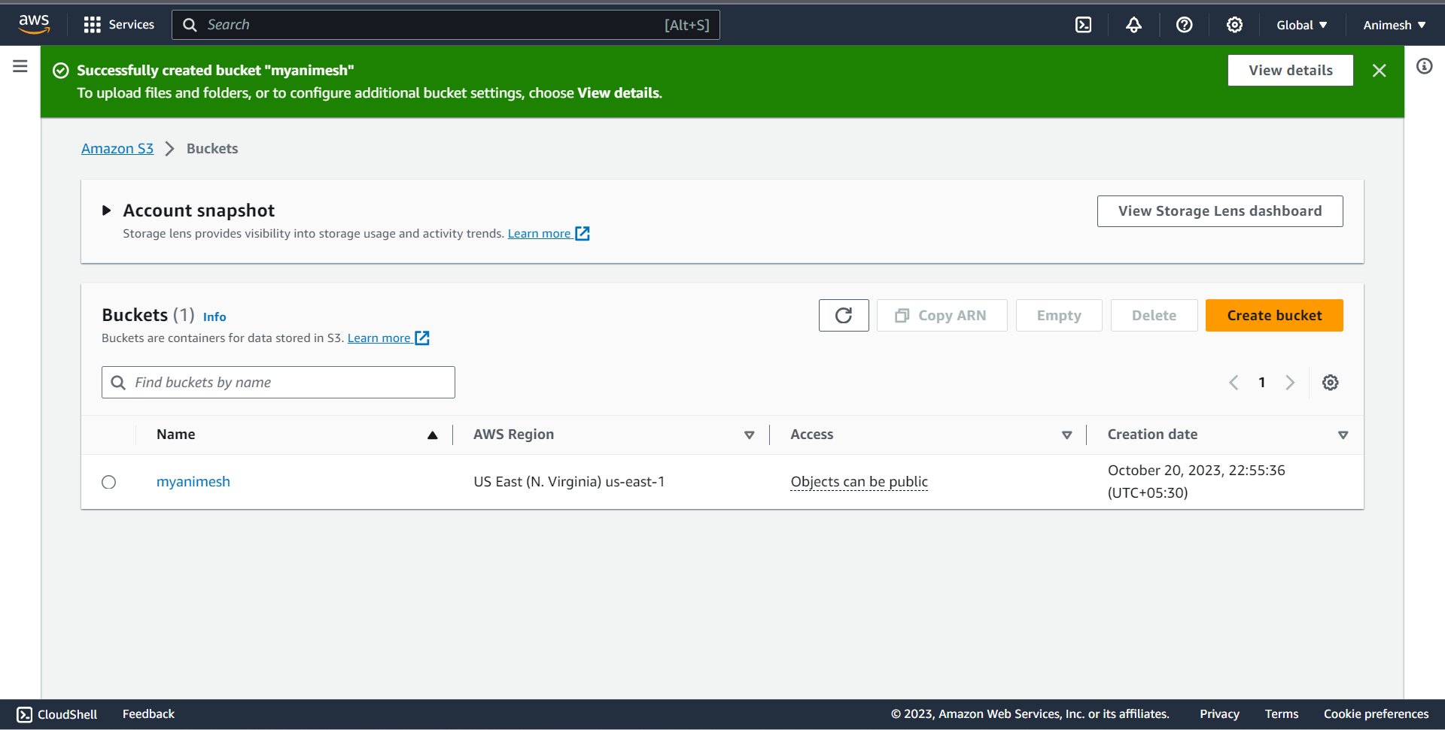



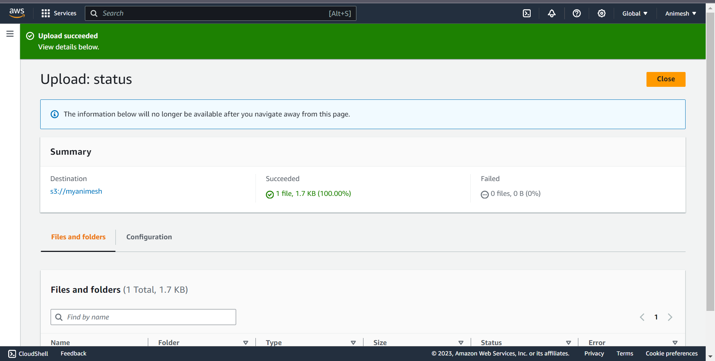

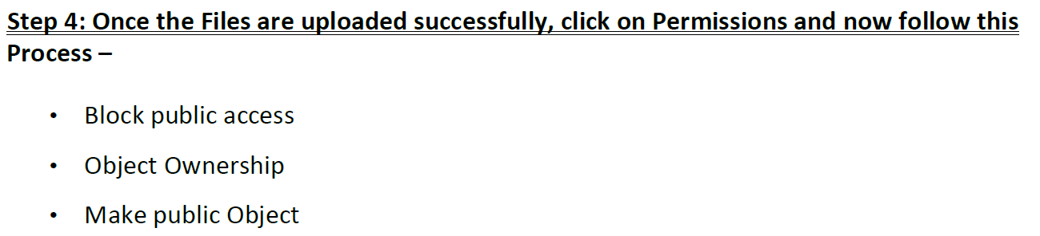

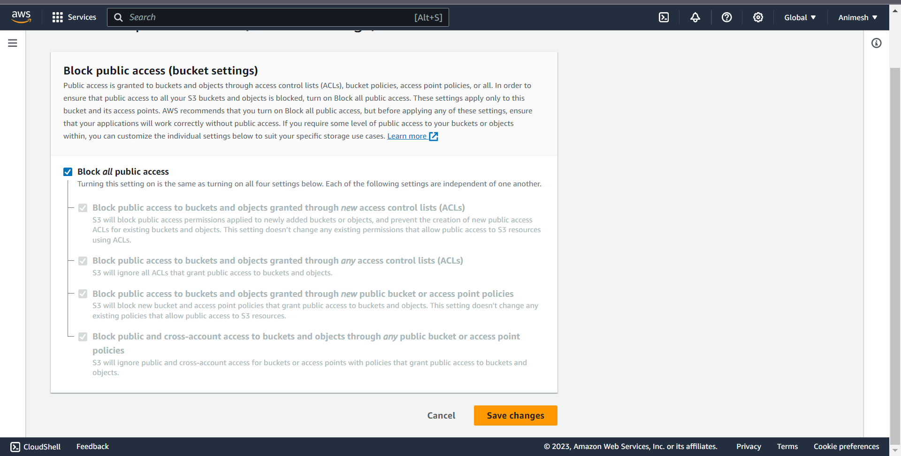

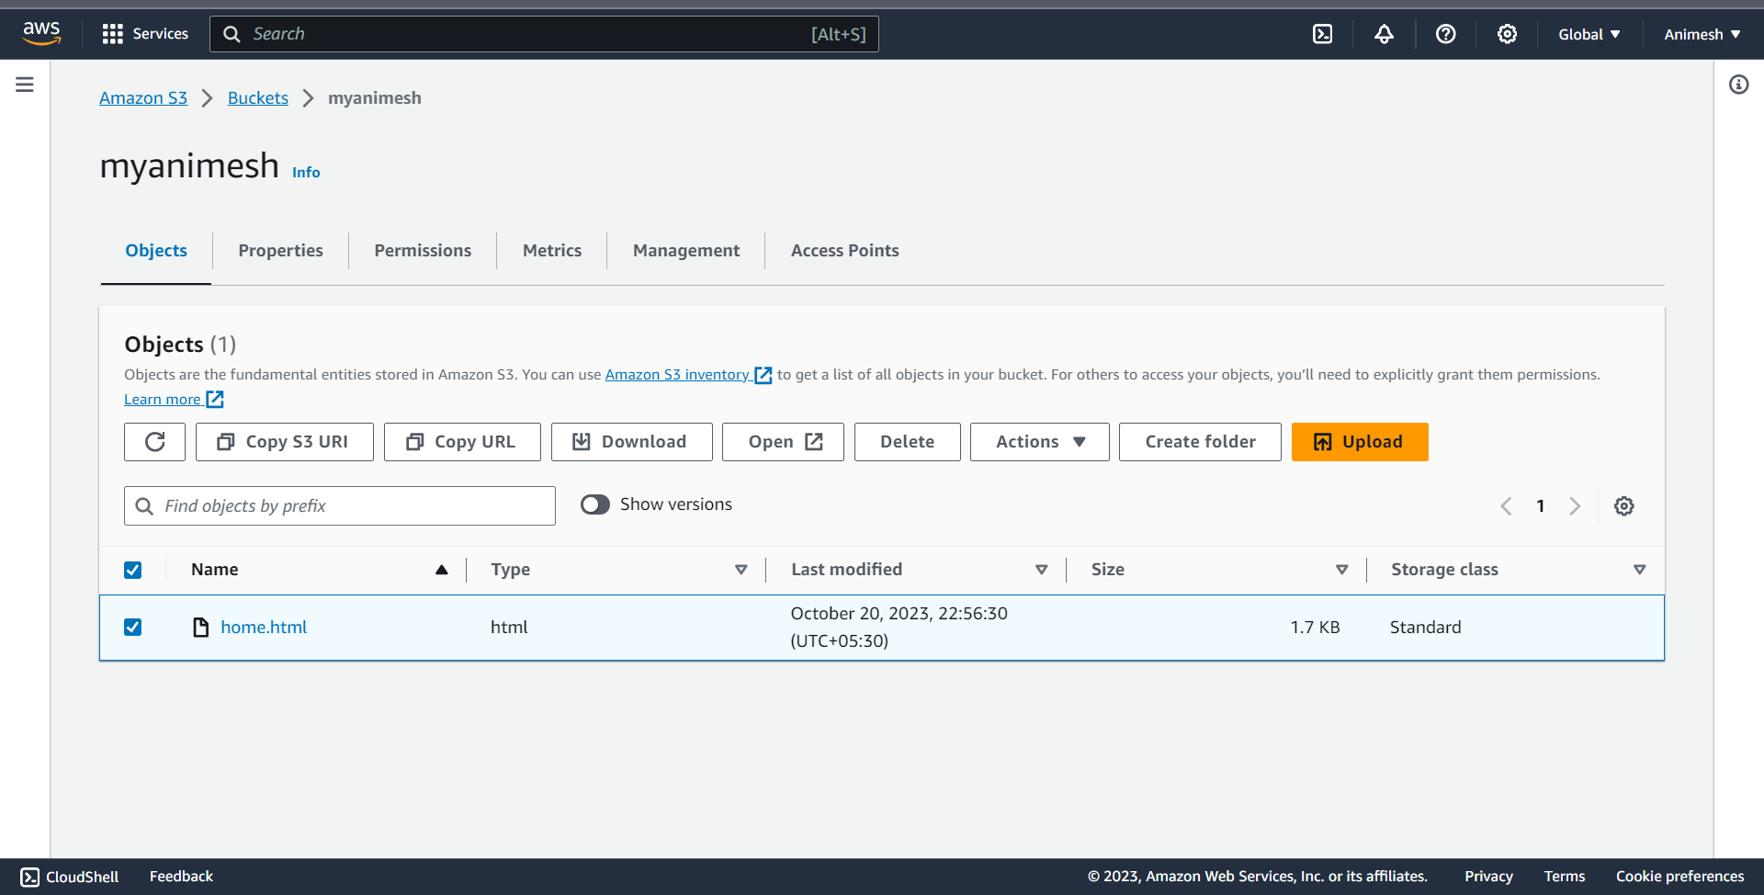

**Step 5: Copy your Object URL**

Now, click on your HTML File Object Name.

Copy the Object URL.

**Step 6**

**Check out your Website!**

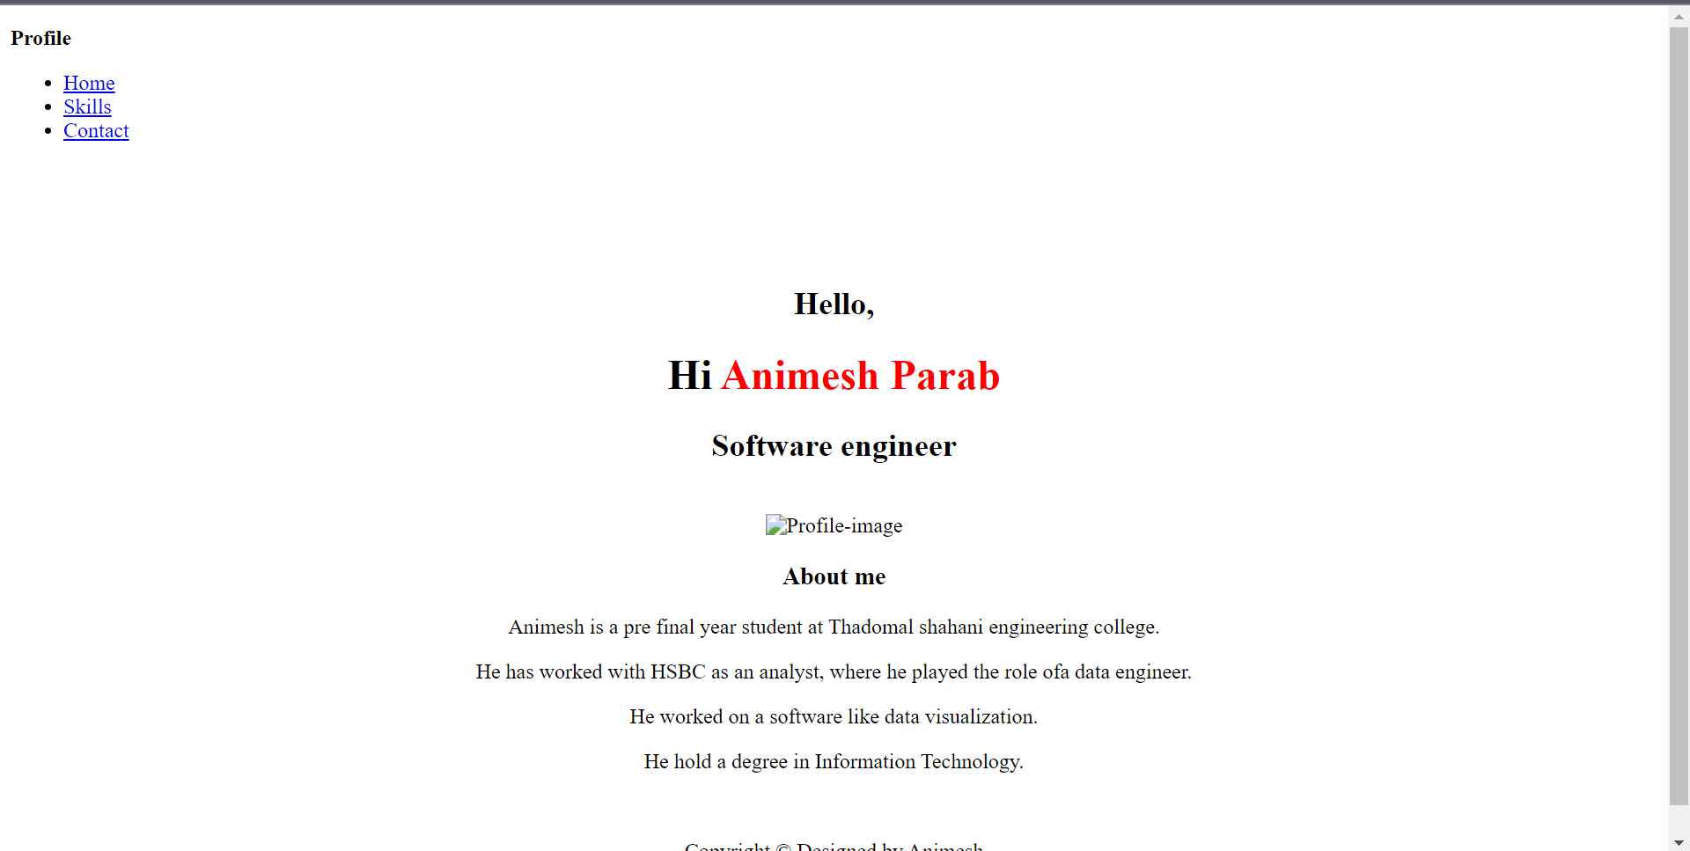

**CONCLUSION** This experiment demonstrated how to

utilize AWS S3, a powerful andcloud storage solution, to host a static web application. S3's ability to serve Directly Paste this URL into the Other Tab or your other System. static content with low latency and high reliability makes it a suitable choice for hosting static websites. By completing this experiment, we gained practical insights into leveraging cloud services for web hosting, which is vital for modern web development and deployment. AWS S3 offers a costeffective and efficient solution for hosting various types of web applications, contributing to the agility and scalability of web development projects.